**935 responsive Web Design Projects - Build a Tribute Page**

**User Story #1:** My tribute page should have an element with a corresponding id="main", which contains all other elements.

**User Story #2:** I should see an element with a corresponding id="title", which contains a string (i.e. text) that describes the subject of the tribute page (e.g. " ").-

**User Story #3:** I should see a div element with a corresponding id="img-div".

**User Story #4:** Within the img-div element, I should see an img element with a corresponding id="image".

**User Story #5:** Within the img-div element, I should see an element with a corresponding id="img-caption" that contains textual content describing the image shown in img-div.

**User Story #6:** I should see an element with a corresponding id="tribute-info", which contains textual content describing the subject of the tribute page.

**User Story #7:** I should see an a element with a corresponding id="tribute-link", which links to an outside site that contains additional information about the subject of the tribute page. HINT: You must give your element an attribute of target and set it to _blank in order for your link to open in a new tab

(i.e. target="_blank").

**User Story #8:** The img element should responsively resize, relative to the width of its parent element, without exceeding its original size.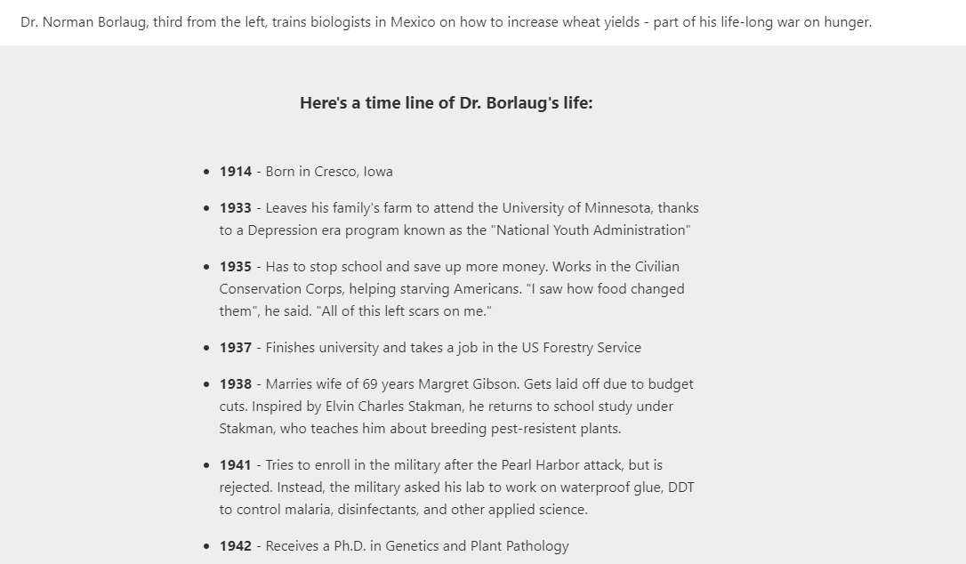

**User Story #9:** The img element should be centered within its parent element**a**